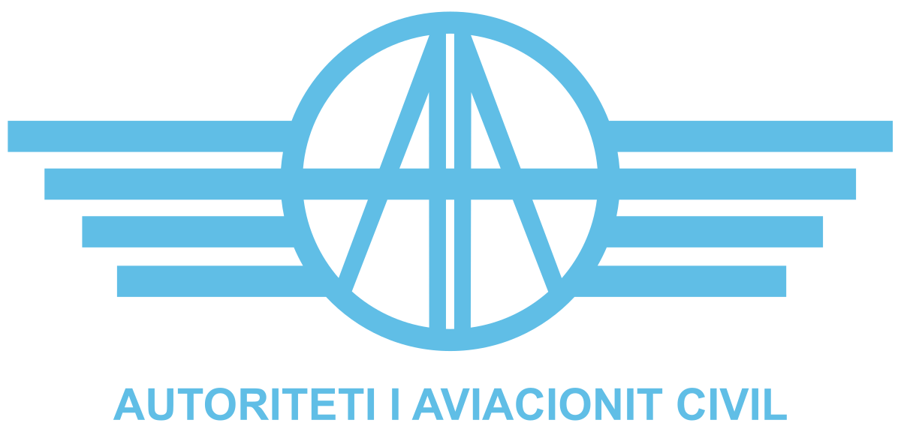

ANNEX I

TERMS OF REFERENCE FOR CONTRACTING AN EXTERNAL EXPERT TO REVISE THE MANUAL ON AIRCREW LICENSING AND CERTIFICATION OF TRAINING ORGANISATIONS

September 2025

Introduction

The Albanian Civil Aviation Authority (hereinafter “ACAA” or “the Contracting Authority”) is a public legal entity established under Law No. 53/2022, On the Organization and Functioning of the Civil Aviation Authority. ACAA has specific regulatory and oversight responsibilities in the field of civil aviation in the Republic of Albania.
In line with ICAO Standards and Recommended Practices (SARPs), EASA requirements, and national regulations — in particular Ministerial Order No. 178, dated 20.12.2023, as amended by Ministerial Order No. 111, dated 31.07.2025, transposing Regulation (EU) No. 1178/2011 on aircrew requirements pursuant to Regulation (EC) No. 216/2008 — the ACAA requires the engagement of an external expert.
The expert will support the revision of the Personnel Licensing (PEL) Manual on Aircrew Licensing and the Manual on the Certification of Training Organisations (TOs), ensuring alignment with international and national regulatory frameworks.

Objectives
  - Main objectives

The objective of these Terms of Reference is to engage a qualified and experienced expert in the field of aircrew licensing and the certification of training organisations. The assignment shall be carried out in accordance with the applicable national and international regulatory framework, including:
- Law No. 96/2020, Air Code of the Republic of Albania;
- Decision of the Council of Ministers No. 1095, dated 24.12.2020, as amended, transposing Regulation (EU) 2018/1139 on common rules in the field of civil aviation and establishing a European Union Aviation Safety Agency;
- Ministerial Order No. 178, dated 20.12.2023, as amended by Ministerial Order No. 111, dated 31.07.2025, transposing Regulation (EU) No. 1178/2011, laying down technical requirements and administrative procedures related to civil aviation aircrew pursuant to Regulation (EC) No. 216/2008 of the European Parliament and of the Council;
- Ministerial Order No. 218, dated 29.12.2023, transposing Regulation (EU) 2020/723 on the acceptance of pilot certificates from other countries;

2.2 Specific Objectives

The expert, acting on behalf of the Albanian Civil Aviation Authority, will be responsible for revising the inspector manuals on aircrew licensing and the certification of training organisations.

The assignment specifically aims to:
- Ensure the manuals are fully compliant with the applicable legal and regulatory framework;
- Provide consultancy on the content, structure, and usability of the manuals;
- Review and update related documentation, including forms and checklists;
- Identify and address gaps to ensure alignment with new amended national legislation;
- Support capacity-building by training ACAA staff on the revised manuals.

Scope of Work

The scope of work to this contract is to ensure that PEL & TO manuals, forms, and checklists related to aircrew licensing and training organization certification are reviewed, updated, and aligned with current regulatory requirements, and to build the capacity of inspectors to effectively use these tools.

Specific Tasks

The following specific task should be undertaken by the expert:

Task | Reference | Context/Subject
Review of Personnel Licensing Manual | ACAA-DTL-PEL | Review of following chapters:  Chapter 2 AIRCREW LICENCING PROCEDURE  Chapter 5 PART-MED PROCEDURE  Chapter 6 EXAMINERS PROCEDURE
Update of Personnel Licensing Manual | ACAA-DTL-PEL | Updating the PEL Manual including compliance verification with latest applicable regulation.  Optimization of processes where needed.
Review of established forms | ACAA-DTL-PEL | Review of current forms and applications established by ACAA including gap analysis.
Updating and designing forms | ACAA-DTL-PEL | Updating forms (application forms)
Review of established checklists | ACAA-DTL-PEL | Review of checklists established by ACAA.
Updating and designing checklists | ACAA-DTL-PEL | Designing checklists for operative use and record keeping of positive compliance verification of for issue, revalidation and renewal of license, rating or certificate.
Review of ATO/DTO/CCTO manual | ACAA-DTL-ATOM | Review of current manual on ATO/DTO/CCTO
Update of ATO/DTO/CCTO manual | ACAA-DTL-ATOM | Updating the ATO/DTO/CCTO Manual including compliance verification with latest applicable regulation.  Optimization of processes where needed.
Training provided to licensing inspectors |  | Training on PEL and ATO/DTO/CCTO use of working instructions and evaluation forms.

Expected Deliverables

During the contracted period, and in close support of the PEL staff, the contracted expert shall, on behalf of the ACAA, be responsible for delivering the following outputs:
a. A comprehensive Gap analysis report for both manuals
b. A reviewed and updated Aircrew Licensing Manual including forms and checklists;
c. Reviewed and Updated ATO/DTO/CCTO Manual including forms and checklists;
d. Training of Aircrew licensing inspectors.

6. Time of implementation

The contracted expert will perform the tasks of the contract during 40 working days in a period of 2.5 months always in cooperation with the Aircrew Licensing staff of ACAA.

7. Place of Delivery

The task related to this contract shall be performed remotely, except for the training of aircrew licensing inspectors that will be on site at the ACAA premises, in Tirana, Albania.

8. Remuneration & Reimbursement of Expenses Fees

8.1 Fees

Expert is entitled to a payment of EUR 450 for each full working day spent performing the tasks assigned to him/her.
8.2 Per diem and travel expenses

This contract does not foresee per diem and travel reimbursements.

9. Reporting
The language of communication for the assignment shall be English.
The contacted expert will produce the required documents in electronic formats, as Microsoft Word documents.
The contracted expert shall submit all deliverables to the ACAA in both electronic format and a signed report for each task performed.

10. Selection Criteria

The expert (auditor/inspector) undertaking the above-mentioned tasks shall meet the following minimum requirements below:

- Holds or has previously held at least a Private Pilot License (PPL), or an equivalent aviation qualification issued or recognized by an EASA competent authority;

- Demonstrates a minimum of seven (7) years of proven professional experience in the field of aircrew licensing within a competent authority in compliance with EASA requirements;

- Possesses valid and official authorization to perform duties as an Aircrew Inspector.

- Proven experience in drafting, developing, and/or revising manuals, procedures, or regulatory documents related to aircrew licensing;

- Evidence of completion of relevant professional training courses related to aircrew licensing and oversight;

- Documented participation in technical events (e.g., workshops, seminars, conferences) related to aircrew licensing and regulatory oversight;

- Excellent command of the English language, both written and spoken.

11. Exclusion Criteria

Participation in this call is only open to natural persons who are not in any of the situations listed below, in particular:

- Bankrupt, subject to insolvency or being wound up, are having their affairs administered by a liquidator or by courts, have entered into an arrangement with creditors, have suspended business activities, are the subject of proceedings concerning those matters, or are in any analogous situation arising from a similar procedure provided for under national legislation or Union law;
- Convicted of an offence concerning their professional misconduct by an administrative decision or a judgement of a competent authority of a Member State which has the force of res judicata;
- Guilty of grave professional misconduct proven by any means which the Contracting Authority can justify including by decisions of the EIB and other international organizations;
- Not in compliance with their obligations relating to the payment of social security contributions or the payment of taxes in accordance with the legal provisions of the country in which they are established or with those of the country of the Contracting Authority or those of the country where the contract is to be performed;
- Subject to a judgement which has the force of res judicata for fraud, corruption, involvement in a criminal organization, money laundering or terrorist financing or any other illegal activity, where such illegal activity is detrimental to the European Union’s financial interests;
- Subject to an administrative penalty for being guilty of misrepresenting the information required by the contracting authority as a condition of participation in the procurement procedure or fail to supply that information or for having been declared to be in serious breach of their obligations under contracts by the budget, or have created an entity in a different jurisdiction with the intent to circumvent legal obligations in the jurisdiction.
In addition to the above, contracts may not be awarded to experts who, during the call, are:
- Subject to a Conflict of interests
- Guilty of misrepresentation in supplying the information required by the Contracting Authority as a condition of participation in the call or fail to supply this information.
12. Confidentiality, Independence and Absence of Conflict of Interest

All experts are expected to ensure that their contractual and professional obligations in particular with regard to confidentiality, independence and absence of conflict of interests are well understood and upheld throughout and after any contract assignment.

At the time of contract assignment, the expert must sign a declaration of ‘Confidentiality, Independence and Absence of Conflict of Interests’ (Annex II to the draft contract) before contract signature.

13. Required documentation
Applications must include all the documents listed below:
- Copy of valid identification document
- Curriculum Vitae in EU format;
- Copy of Diploma
- Copy of pilot license
- Copy of inspector`s authorization
- List of the trainings and qualifications, accompanied by relevant training certificates
- Documented evidence of participation in Technical Events, such as seminars, workshops, or conferences
- Proof of English Language Proficiency at least ICAO Level IV
- Applicants must confirm in their application that they are not in any of the situations listed in section 11 – exclusion criteria;
- Applicants should justify how they fulfil the minimum criteria such as 7 years of relevant work experience. As evidence one or more activities and assignments relevant to the scope of area shall be provided.
- It is strictly required that applications are submitted in the requested format and include all information/documentation necessary to enable the ACAA to assess them. Failure to respect these requirements may result in the rejection of the application.

Before awarding a contract, the ACAA reserves the right to request any additional supporting documentation in order to verify the applicant’s qualifications, professional experience and/or language capabilities (i.e. copies certificates, diplomas, references etc.).

Please also note that before contract assignment the ACAA may request an interview in order to establish a first contact with the expert and/or assess/verify any information provided in the application.

1 full working day shall consist of 8 hours (excluding breaks and travelling time)

