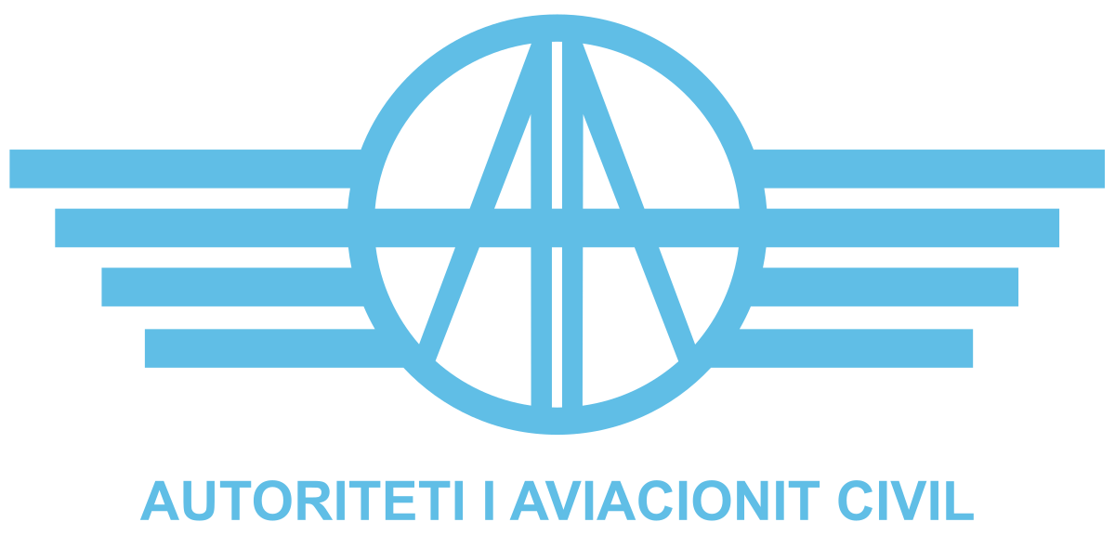

ANNEX I

TERMS OF REFERENCE FOR CONTRACTING AN EXTERNAL EXPERT AS MEDICAL ASSESSOR OF ACAA

Shtator 2025

Introduction

Albanian Civil Aviation Authority, (hereinafter “ACAA” or “the Contracting Authority”) is a public legal body, established by law No. 53/2022, “For the organization and functioning of Civil Aviation Authority”, which has been given specific regulatory and oversight tasks in the field of civil aviation transport in the Republic of Albania.
A contracted expert is needed for Albanian CAA as required by ICAO standards and EASA, as well as National Regulation, in particular Minister Order Nr. 178, date 20.12.2023, amended by the Minister Order No. 111, dated 31.07.2025, transposition of Regulation (EU) No. 1178/2011),” laying down technical requirements and administrative procedures related to civil aviation aircrew pursuant to Regulation (EC) No 216/2008 of the European Parliament and of the Council”, as amended, ARA.MED.120 and related AMC ARA.MED.120, AMC2 ARA.MED.120; ARA.MED.150 and related AMC1 ARA.MED.150; ARA.MED.245; ARA.MED.250 and ARA.MED.255; ARA.MED.315 and related AMC 1 ARA.MED.315 (a); ARA.MED.325

Objectives
  - Main objectives

The objective of these Terms of Reference is to contract an individual expert who owns a certificate as aeromedical examiner in accordance with in accordance with the Minister Order No. 178, dated 20.12.2023, “On the approval of the regulation on technical requirements and administrative procedures related to the flight crew of civil aviation”, amended by the Minister Order No. 111, dated 31.07.2025, transposing Commission Regulation (EU) No 1178/2011 of 3 November 2011, laying down technical requirements and administrative procedures related to civil aviation aircrew pursuant to Regulation (EC) No 216/2008 of the European Parliament and of the Council, who will be required to conduct on behalf of the Albanian CAA, the tasks associated with the certification, evaluation and oversight function of the ACAA of the commercial air transport operators, to ensure compliance with the requirements of Law No. 96/2020, “Air Code of the Republic of Albania”, Law No. 9658/2006 “ECAA Agreement”, Regulation (EC) No 1139/2018 of the European Parliament and of the Council “On common rules in the field of civil aviation and establishing a European Aviation Safety Agency, as well as Regulation No. 1178/2011),” laying down technical requirements and administrative procedures related to civil aviation aircrew pursuant to Regulation (EC) No 216/2008 of the European Parliament and of the Council”.
These tasks will include but will not limit to the processing of the related technical documentation to be reviewed and assessed, inspections and audits conduct, preparation of relevant reports and respective tasks related to the follow up.

Specific Objectives

The objectives of the ACAA in the field of civil aviation are defined in the Article 8 of the Law No. 96/2020, “Air Code of the Republic of Albania”, which includes consideration of any emerging ICAO and EASA provisions.

This assignment will contribute to these objectives by addressing the issues outlined in Section 2.

The tasks to be performed by the contracted expert will be:

- to ensure compliance with the applicable Conventions, Agreements, Laws, flight safety and Minister’s Ordinances/Orders and relevant guidance materials in the Civil Aviation;
- to ensure the implementation of the relevant specific requirements of Minister Order No. 178, dated 20.12.2023, amended by the Minister Order No. 111, dated 31.07.2025 transposition of Regulation (EU) No. 1178/2011), in area Aeromedical requirements, specifically paragraph ARA.MED.120 and related AMC ARA.MED.120, AMC2 ARA.MED.120; ARA.MED.150 and related AMC1 ARA.MED.150; ARA.MED.245; ARA.MED.250 and ARA.MED.255; ARA.MED.315 and related AMC 1 ARA.MED.315 (a); ARA.MED.325
- based on the experience gained so far as experiences certified Aeromedical examiner for civil aviation, the contracted expert should perform tasks associated to Annex IV, PART-MED evaluation, certification, oversight, record keeping considering and assessing the Acceptable Means of Compliance, based on the experience.

Scope of Work

Upon request of ACAA, the expert shall perform the tasks associated to the evaluation, certification or approval, oversight and record keeping of Aeromedical center and Aeromedical Examiners and evaluated personnel.

Minister Order / Regulation | Scope of Work
Decision of the Council of Ministers No. 1095, dated 24.12.2020 On the approval of the essential requirements in the field of civil aviation (Approximation with Basic Reg. (BE) Nr. 2018/1139, dated 04.07.2018), repealing the Basic Regulation (EC) No 216/2008  Minister Order Nr. 178, datë 20.12.2023, amended by the Minister Order No. 111, dated 31.07.2025, transposition of Regulation (EU) No. 1178/2011, as amended;(AMC, GM) to this Regulation. | - Oversight (audits/inspections/evaluation of  specific documentation)  - AeMC certification/oversight  - AME certification/oversight  - Secondary Review procedures  - Review of examination reports  - Record keeping

Specific Tasks

The following specific task should be undertaken by the expert:

- Details of aeromedical examinations and assessment submitted by AME and AeMC
- Certification
- Oversight
- Enforcement measures
- Secondary review procedure

Expected Deliverables

The contracted expert in support to PEL staff, during the contracted period shall conduct on behalf of ACAA, the following tasks:

- Oversight functions related to aero-medical certification field AME/AeMC and AME training facilities
- Issue and evaluation of AeMC certification
- Evaluation of major and minor changes of AeMC
- Issue, revalidation and renewal of AME certificate
- Oversight of AME/AeMC Facilities and activities
- Follow up of findings and relevant corrective action measure for AME/AeMC
- Perform the aero-medical assessment of applicants for, or holders of, medical certificates after
referral to the licensing authority
- Limitation, suspension or revocation of an AME/AeMC certificate
- To determine the applicant’s fitness for the issue of a medical certificate with one or more limitation(s) as necessary
- Review of examination reports
- Secondary Review procedures
- Rulemaking tasks, Aeromedical Manual, procedures, forms
- Evaluation of SMS AeMC Manual
- Record keeping
- Participate in the training session arranged by Albanian Civil Aviation Authority (ACAA), intended to familiarize with the legislation and regulation applied by ACAA. Participation in the training session will be counted out from the planned working days. Modalities of the training session will be administered through the Internal Order of the Executive Director. In this case no Fee shall be payable and only a per diem shall be applied pursuant to Article 8.2 of these ToR.

6. Time of implementation

The contracted expert as Aeromedical Assessor qualified as experienced AME, will be available upon ACAA request in specific cases. The time of implementation of this contract will be one year with the possibility of extension.
The contracted expert shall perform the above tasks in 132 working days always in cooperation with the Sector of Personnel Licensing staff of ACAA.

If the subject of the relevant task allows the expert to perform it remotely, both parties (Expert and ACAA) agree in performing it remotely.

- For the Record keeping tasks, to assess medical records and store and update CAA archive, related to the certified personnel, are evaluated an overage of 28 working days per year.
- For the oversight tasks, Inspections and audit, preparation of audit plan and follow up, also evaluation of borderline cases and secondary review, are evaluated an average of 30 working days per year.
- Rulemaking tasks, Aeromedical Manual, procedures, forms and check list,74 working days per year.

7. Place of Delivery

Place of delivery shall be defined for each specific task/ activity, however in general services shall be performed in Tirana, Albania, premises of ACAA, facilities of AME/AeMC and remotely.

8. Remuneration & Reimbursement of Expenses Fees

8.1 Fees

Expert is entitled to a payment of 120 € (one hundred and twenty euro) for each full working day spent performing the tasks assigned to him/her.

8.2 Per diem

In addition, experts performing tasks outside their place of residence may be entitled to a flat rate subsistence allowance and reimbursement for travel expenses.
The subsistence allowance (per diem) is paid as a flat rate and is considered to cover all expenses incurred at the place of the meeting or assignment, including the costs of accommodation, meals and local travel.

The amount of the subsistence allowance is the standard rate published by the European Commission:
(https://international-partnerships.ec.europa.eu/document/download/167fc5d8-015b-4a51-85b1-266891fbcc21_en?filename=per-diem-rates-20241108_en.pdf) for the country where the assignment takes place.

The full amount will be paid for assignments of more than one day for those days which include an overnight stay. For one-day assignments, 25 % of a full per diem will be paid.

For the day of return (which thus includes no overnight stay) from assignments of more than one day (which include overnight stay), and when the return to the point of departure is later than 8 p.m., 25 % of a full per diem will be paid.

8.3 Travel expenses

Travel expenses are reimbursed on the following basis:

- international travel from the place of residence of the expert (point of departure) to the location of the assignment;
- travel from another location other than the place of residence or the location of the assignment, under certain conditions, on a case-by-case basis, and when clearly specified and agreed upon in advance by the ACAA.
- In economy class, at the lowest rates available at the moment of the notification of the assignment, considering the time and/or special features of the assignment.

The following supporting documents need to be provided and submitted to the responsible staff member within the ACAA:
- the ticket or electronic booking;
- the travel agency’s invoice (when applicable) or other prove of payment;
- the boarding pass(es);

ACAA reserves the right to reject payment of travel expenditures if the most direct route and the most economical fare criteria have not been applied.

9. Reporting
The language of communication for the assignment shall be English. The Inspector will produce the documents in both electronic and hard copy formats, as Microsoft Word documents, and submit them to the ACAA for each task performed.

10. Selection Criteria

The expert (auditor/inspector) undertaking the above-mentioned tasks shall meet the following minimum requirements below:

- The medical assessor shall be graduated and licensed in medicine;
- postgraduate work experience in medicine of at least 5 years;
- specific knowledge and experience in aviation medicine (trainings);
- have experience of aero-medical practice and have undertaken a minimum of 25 medical examination Class 2 and a minimum of 50 medical examination of Class 3.
- maintain their medical professional competence in aviation medicine;
- undertaking regular refresher training;
- participating in international aviation medicine conferences;

11. Exclusion Criteria

Participation in this call is only open to natural persons who are not in any of the situations listed below, in particular:

- Bankrupt, subject to insolvency or being wound up, are having their affairs administered by a liquidator or by courts, have entered into an arrangement with creditors, have suspended business activities, are the subject of proceedings concerning those matters, or are in any analogous situation arising from a similar procedure provided for under national legislation or Union law;
- Convicted of an offence concerning their professional misconduct by an administrative decision or a judgement of a competent authority of a Member State which has the force of res judicata;
- Guilty of grave professional misconduct proven by any means which the Contracting Authority can justify including by decisions of the EIB and other international organizations;
- Not in compliance with their obligations relating to the payment of social security contributions or the payment of taxes in accordance with the legal provisions of the country in which they are established or with those of the country of the Contracting Authority or those of the country where the contract is to be performed;
- Subject to a judgement which has the force of res judicata for fraud, corruption, involvement in a criminal organization, money laundering or terrorist financing or any other illegal activity, where such illegal activity is detrimental to the European Union’s financial interests;
- Subject to an administrative penalty for being guilty of misrepresenting the information required by the contracting authority as a condition of participation in the procurement procedure or fail to supply that information or for having been declared to be in serious breach of their obligations under contracts by the budget, or have created an entity in a different jurisdiction with the intent to circumvent legal obligations in the jurisdiction.
In addition to the above, contracts may not be awarded to experts who, during the call, are:
- Subject to a Conflict of interests
- Guilty of misrepresentation in supplying the information required by the Contracting Authority as a condition of participation in the call or fail to supply this information.
12. Confidentiality, Independence and Absence of Conflict of Interest

All experts are expected to ensure that their contractual and professional obligations in particular with regard to confidentiality, independence and absence of conflict of interests are well understood and upheld throughout and after any contract assignment.

At the time of contract assignment, the expert must sign a declaration of ‘Confidentiality, Independence and Absence of Conflict of Interests’ (Annex II to the draft contract) before contract signature.

13. Required documentation
Applications must include all the documents listed below:
- Curriculum Vitae in EU format;
- Copy of Diploma
- Copy license in medicine/ Medical Order
- AME Certificate (Certified);
- List of the trainings and qualifications with the period of validity;
- Applicants must confirm in their application that they are not in any of the situations listed in section 11 – exclusion criteria;
- Applicants should justify how they fulfil the minimum criteria such as 5 years of relevant work experience. As evidence one or more activities and assignments relevant to the scope of area shall be provided.
- Evidences of required experience of aero-medical practice of a minimum 25 medical examination Class 2 and a minimum of 50 medical examination of Class 3.
- It is strictly required that applications are submitted in the requested format and include all information/documentation necessary to enable the ACAA to assess them. Failure to respect these requirements may result in the rejection of the application.

Before awarding a contract, the ACAA reserves the right to request any additional supporting documentation in order to verify the applicant’s qualifications, professional experience and/or language capabilities (i.e. copies certificates, diplomas, references etc.).

Please also note that before contract assignment the ACAA may request an interview in order to establish a first contact with the expert and/or assess / verify any information provided in the application.

1 full working day shall consist of 8 hours (excluding breaks and travelling time)

