Albanian Civil Aviation Authority

Guidance Material & Information
On initial
Air Operator License
&
Air Operator Certificate

Table of Content
GM 0 Introduction 5
  - Purpose of this GM/INFO 5
  - Related Regulations 5
  - Related Material and Documents 5
  - Background 5
  - Terms and Conditions 7
GM 1 Pre-certification Phase 8
GM 2 Formal Application Phase 11
GM 3 Document Evaluation Phase 12
GM 4 Demonstration and Inspection Phase 13
GM 5 Final Certification Phase 14
GM 6 Costs and Time Schedule 15
GM 7 Appendices 16
  - Appendix 1 – Check list before Pre-certification phase 16
  - Appendix 2 – Check list Formal Application Phase 17
  - Appendix 3 – Regulations, Documents, Homepage addresses 18
  - Appendix 5 – Flow Charts (The 5 Phases Certification Process) 21
GM 8 Air Operator License 26
GM 9 Aircraft Certificates (C of Registration, C of Airworthiness (&ARC), Noise Certificate, Radio License), CAMO 36

List of Abbreviations
The following abbreviations are within this Administrative Guidance Material:

Abbreviation | Definition
AEA | Association of European Airlines
AGL | Administrative Guidance Leaflet
AMC | Acceptable Means of Compliance
AOL | Air Operator License
AOC | Air Operator Certificate
C of R | Certificate of Registration
C of A | Certificate of Airworthiness
ARC | Airworthiness Review Certificate
ATA | Air Transport Association
ACAA | Albanian Civil Aviation Authority
EASA | European Aviation Safety Agency
ECAC | European Civil Aviation Conference
FAA | Federal Aviation Administration
FSF | Flight Safety Foundation
GM/INFO | Guidance Material / Information
IATA | International Air Transport Association
ICAO | International Civil Aviation Organisation
LoR | Log of Revision
NAA | National Aviation Authority
NPA | Notices of Proposed Amendments
OD | Operational Directives
PM | Project Manager

Log of Revision (LoR)

Date | Issue | Revision | Highlight of Revision
24.11.2016 | 1 | 0

List of Effective Pages

Page | ISS/REV | Date
CP | 1/0 | 24.11.2017
ADMIN | 1/0 | 24.11.2017
ToC 1 | 1/0 | 24.11.2017
ABB 1 | 1/0 | 24.11.2017
1 | 1/0 | 24.11.2017
2 | 1/0 | 24.11.2017
3 | 1/0 | 24.11.2017
4 | 1/0 | 24.11.2017
5 | 1/0 | 24.11.2017
6 | 1/0 | 24.11.2017
7 | 1/0 | 24.11.2017
8 | 1/0 | 24.11.2017
9 | 1/0 | 24.11.2017
10 | 1/0 | 24.11.2017
11 | 1/0 | 24.11.2017
12 | 1/0 | 24.11.2017
13 | 1/0 | 24.11.2017
14 | 1/0 | 24.11.2017
15 | 1/0 | 24.11.2017
16 | 1/0 | 24.11.2017
17 | 1/0 | 24.11.2017
18 | 1/0 | 24.11.2017

GM 0 Introduction
All Guidance Material / Information (GM/INFO) are intended to assist the organisation/operator in administrative matters. The administrative requirements and processes will facilitate liaising with the Albania Civil Aviation Authority (ACAA). It is to be considered a tool for the organisation/operator in order to ease processes of obtaining required and defined approvals and authorisations issued by the Albanian Civil Aviation Authority. Using the GM/INFO will be conducive to establishing compliance with ACAA requirements and will lead through the respective certification or variation process in regard to administrative tasks.

  - Purpose of this GM/INFO
This Guidance Material / Information (GM/INFO) describes the process of applying for and obtaining an Air Operator License, Aircraft Certificates [C.of Registration, C.of Aworthiness(+ARC), Radio License, Noise Certificate] and Air Operator Certificate (AOC) to conduct commercial air transport operations under the Minister’s Orders no.3/2011 (Basic Regulation no.216/2008), no 17/2010 (Reg. (EU) 1008/2008) no.151/2014 (Reg.(EU) no.965/2012). The licensing and certification process may appear to be a complex undertaking, particularly to a “first-time” operator. This GM/INFO provides basic information applicable to the certification process.
There are various methods acceptable for the purpose of establishing Operations Manuals. This GM/INFO does not deal with these possible methods but will assist the applicant in completing the “five phase certification process” with minimal delays and complications. Additional information will be found in the related documentation as referenced under paragraph 2 and 3 below.

  - Related Regulations
Appendix 4 shows a list of related regulations applicable to the AOL & AOC first certification process.

  - Related Material and Documents
For certain areas (e.g. some subchapters of Operations Manuals) ACAA publishes EASA Operations Manual template and compliance checklists. These documents provide more information for specific subjects.
In addition, ACAA publishes Operational Directives (OD) for particular areas of published regulations in order to clarify or define the relevant issues in more detail where required.

  - Background
To conduct Commercial Air Transport Operations under M.O. no 17 date 02.09.2010 amended by M.O.14 date.09.09.2011 and Council Regulations (EEC) 1008/2008, an operator must be a citizen as defined in the Albanian Law (to be confirmed with AOL application form). The ACAA recognises the responsibility of Commercial Air Transport Operators to provide air transportation with the highest possible degree of safety in the public interest. The certification process is designed to ensure that prospective AOC holders understand and are capable of fulfilling this duty. When satisfactorily completed, the certification process should ensure that the operator is able to comply with the Albanian Air Code Law 10040/2008, ACAA regulations, and the international standards pertaining to the operation of aircraft as published in relevant ANNEXES to the convention on international civil aviation organisation (ICAO).
There are five phases in the air operator certification process defined. Each phase is described in sufficient detail to provide a general understanding of the entire certification process. The five phases are:

    - Pre-application
    - Formal Application
    - Document Evaluation
    - Inspection and Demonstration
    - Certification
In some cases, the guidance and suggested sequence of events in this GM/INFO may not be entirely appropriate. In such situations, the ACAA and the operator should proceed in a manner that considers existing conditions and circumstances. The operator, however, should not expect to be certificated until the ACAA is assured that the Albanian Air Code law no 10040/2008, its Civil Aviation Orders/Regulations and the applicable EU regulations will be complied with in an appropriate and continuing manner.
The five phases are to be seen as steps. In order to continue the certification process, the previous phase shall be completed. Therefore, no continuation of the certification process will be undertaken if not all points, articles and individual tasks are completed in the previous certification phase.

PHASE 1 | PHASE 2 | PHASE 3 | PHASE 4 | PHASE 5
Pre-Application Phase | Formal Application Phase | Document Evaluation Phase | Inspection and Demonstration Phase | Certification Phase

The Guidance Material / Information (GM/INFO) has been written to give an overview about the Air Operator Certificate (AOC) 5 phase certification process in general. The 5 phase certification process is a standard published by the International Civil Aviation Organisation (ICAO). Each phase must be completed before starting the next one.
An application for an AOC is a time consuming and expensive work. This work is very often underestimated. The Albanian Civil Aviation Authority (ACAA) accepts an AOC application by Commission Regulation (EU) No 965/2012 standards only. All application forms must be duly signed by the people requested in original, electronic signature are not yet accepted.
The project may be delayed because of other applications already in progress or due to the quality of the submissions or missing parts. Even if one of the proposed nominated person has missed the necessary score in the assessment, a project could get further delay until all management personnel has been accepted.
If an applicant has the need for further information, please write to the following address:
Albanian Civil Aviation Authority
Rr: “Sulejman Delvina”, no.1,1020, P.O.Box 205,
Tirana, Albania
email: info@acaa.gov.al

  - Terms and Conditions
When used throughout the Administrative Guidance Leaflet the following terms shall have the meaning as defined below:

Term | Meaning | Reference
shall, must, will | These terms express an obligation, a positive command. | EC English Style Guide: Ch. 7.19
may | This term expresses a positive permission. | EC English Style Guide: Ch. 7.21
shall not, will not | These terms express an obligation, a negative command. | EC English Style Guide: Ch. 7.20
may not, must not | These terms express a prohibition. | EC English Style Guide: Ch. 7.20
need not | This term expresses a negative permission. | EC English Style Guide: Ch. 7.22
should | This term expresses an obligation when an acceptable means of compliance should be applied . | EASA Acceptable Means of Compliance publications  ACAA policies and requirements
could | This term expresses a possibility. | http://oxforddictionaries.com/ definition/english/could
ideally | This term expresses a best possible means of compliance and/or best experienced industry practice. | ACAA recommendation

- The use of the male gender should be understood to include male and female persons.
Note: To highlight an information or editorial note, a specific note box is used.

GM 1 Pre-certification Phase
The operator is informed by the ACAA to acquire the required information through the official website in order to follow the available guidance material. If the prospective operator intends to proceed with certification, DAMO-OPSM-FRM-001 and ACAA Form 4 (EASA Form 4) related to the intended management functions (e.g. Nominated Persons) shall be mailed to the applicant or downloaded by the applicant from the official ACAA website. An instruction for completion of the AOC application form is to be found on separate publication. The AOC application form and all EASA Form Four should be completed, signed by the prospective operator, and returned to ACAA Certification. Additionally, the operator will submit the business plan, the documents for proof of financial background and sufficient cash flow, the plan of intended infrastructure, a presentation of the network and a written statement of fulfilling the required legal matters.
The Minister Order no. 151/2014 (transposition of Air-OPS Reg.(EU) No 965/2012) (ORO.GEN.130, ORO.GEN.135 and ORO.GEN.135(a)) establishes basic management positions and the minimum qualifications for air operators proposing to conduct commercial air transportation operations. Individuals assigned to the required management positions / functions are expected to have a thorough knowledge of the national and international regulations, operating provisions. This attachment (EASA Form Four) must contain resumes of the qualifications, licenses (including license numbers), ratings, and aviation experience / education for each of the following positions (CV), or their equivalent:
  - Accountable Manager (ACM)
  - Compliance Monitoring Manager (CMM)
  - Safety Monitoring Manager (SMM)
  - Nominated Person Flight Operations (NP FO)
  - Nominated Person Ground Operations (NP GO)
  - Nominated Person Crew Training (NP CT)
  - Post Holder Continuing Airworthiness (PCA)
  - Deputy Accountable Manager (DACM)
  - Deputy Compliance Monitoring Manager (DCMM)
  - Deputy Nominated Person Flight Operations (DPFO)
  - Deputy Nominated Person Ground Operations (DPGO)
  - Deputy Nominated Person Crew Training (DPCT)
  - Deputy Post Holder Continuing Airworthiness (DPCA)
ACAA personnel will review the DAMO-OPSM-FRM-001, Form 4, CV and all other submitted documents. If the information is incomplete or erroneous, the forms will be returned to the prospective operator with the reasons for its return. If the information is complete and acceptable, the ACAA will invite the Nominated Person and deputy Nominated Person candidates to the next available assessment session, where the candidates will undergo the assessment process.
The ACAA will evaluate the financial background of the operator and its legal aspect, will assess the operator’s business plan and evaluate the availability of the necessary infrastructure and logistic.

Note: Only after all the above mentioned pre-requisites are met and found acceptable, continuation of this process will be granted.
The purpose of the pre-application meeting is to confirm the information on the application form and to provide critical certification information to the applicant. It is imperative that the operator’s Accountable Manager and accepted Nominated Persons and deputy Nominated Persons attend the pre-application meeting and be prepared to discuss in general terms the plans and specific aspects of the proposed operation. Many problems can be avoided by discussing all aspects of the proposed operation and the specific requirements, which must be met to be certificated as an air operator.
It is important to establish good working relationships and clear understandings between the ACAA and the operator’s representatives. The ACAA recognizes that a wide range of capabilities and expertise exists among operators. This background experience will be considered by the ACAA and adjusted to during these initial meetings.
    - To help promote understanding throughout the certification process, an application information package will be provided when requested or latest at the pre-application meeting.
The Minister Order no 151/2014 (Reg.(EU) No 965/2012) specifies that an application for an AOC shall be made in a form and manner acceptable to the Authority; and containing any information the Authority requires the applicant to submit. It is important to understand the minimum documentation necessary to be considered acceptable for a formal application. Formal application must be made on a form provided by the Authority (appl. form) and by a letter requesting certification as an air operator. The Accountable Manager must sign the form and letter. The submitted letter should include a statement that the letter serves as formal application for an Air Operator Certificate.
Schedule of Events / Implementation Schedule: The schedule of events is a key document that lists items, activities, programs, and aircraft and/or facility acquisitions that must be accomplished or made ready for the ACAA’s inspection before certification. It should include dates when the crewmembers will start company indoctrination procedures and/or training. In addition, the schedule of events should include dates when maintenance personnel training will start; when maintenance facilities will be ready for the ACAA’s inspection; when each of the required manuals will be available for evaluation; when aircraft will be ready for inspection; when terminal facilities will be ready for inspection and demonstration flights are planned to be performed. These estimated dates must be logical in terms of sequence. For example, the estimated date for crew member basic company procedures indoctrination ground training to begin should be after the date that sections of the company manuals pertinent to crewmember performance will be completed and submitted. The temporary time schedule shows the operator’s intention of time management. Nevertheless, a definite implementation schedule which will replace the temporary schedule will be adapted and agreed later during the formal application phase in relation to realistic time management and available human resources. The definite implementation schedule is subject to acceptance by the ACAA project manager PM and is then the agreed document during the entire certification process.
Operations Manuals System: These manuals, which have to be issued in separate parts for specific users, contain policies, instructions, information and duties and responsibilities, for the safe operation and airworthy aeroplanes. The entire manual system shall be completely developed at the time of formal application.
It is recognised that aircraft acquisition, facility and subcontractor arrangements and certain training and checking program elements may not be fully developed at the time of formal application. However, the Operations Manual Part D, Training, established in accordance with the decided Training Concept must be completed to the maximum extend as possible. The company initial training and checking curriculum portion of the OM-D must be attached to the formal application letter.
Documents of Purchase, Leases, Contracts, and/or Letters of Intent: These attachments should provide evidence that the operator is in the process of actively procuring aircraft, facilities, and services appropriate to the type of operation proposed. If formal contracts are not completed, letters or other documents showing preliminary agreements or intent will suffice until such date as determined by the Authority.
      - Aircraft
      - Station facilities and services
      - Weather gathering facilities and services
      - Communications facilities and services
      - Maintenance facilities and services
      - Maintenance contractual arrangements
      - Aeronautical charts and related publications
      - Aerodrome analysis and obstruction data
      - Aircraft take-off and landing performance tables related to individual runways.
      - Contract training and training facilities
Compliance List: This listing contains all applicable articles and paragraphs of the Minister Order no 151/2014 (Reg.(EU)no. 965/2012), where the Operator states that he is compliant with the respective requirement. Additionally, the list indicates the chapters and/or subchapters within the Operations Manual System, where the appropriate compliance is described. The fully completed list of compliance ensures each applicable regulatory requirement has been adequately addressed in the appropriate manuals, programs, and/or procedures. Furthermore, on the OM compliance list, where applicable, formal acceptance and approvals are included.
The director defines a project manager (PM) who will lead the mentioned project and guide the operator through the whole certification process.

GM 2 Formal Application Phase
The formal application shall be submitted to ACAA as early as possible.
The ACAA will review the application to determine that it contains the required information, documents and attachments. If there are omissions or errors, the formal application and all attachments will be returned with a letter outlining the reasons for its return. If the operator has a good understanding of the requirements, the formal application should be of sufficient quality to allow any omission, deficiency, or open question to be resolved during the formal application meeting.
The Operator’s Accountable Manager, Compliance Monitoring Manager, Nominated Person and Deputy Nominated Person personnel shall attend the formal application meeting. The purpose of the meeting is to present the project manager, delegated inspectors, experts and specialists and to discuss the formal application and resolve omissions, deficiencies, or answer questions from either party. For example, this meeting may be used to resolve questions concerning the applicant’s package or scheduling date conflicts, or to ensure the applicant understands the certification process. This meeting should also be used to reinforce open communication and working relationships.
If the formal application meeting is successful, the operator is provided with a letter acknowledging receipt and acceptance of the package by the project manager or head of section. The ACAA’s acceptance of a formal application does not constitute approval or acceptance of individual attachments.

GM 3 Document Evaluation Phase
After the formal application has been accepted, ACAA inspectors will begin a detailed evaluation of all submitted manuals, forms and documents. Inspection of the Operations Manual System may, depending on the size of operation, be done on the whole manual or on different parts at different times with different experts. The ACAA will endeavour to complete these evaluations in accordance with the agreed schedule of events. If a manual or document is incomplete or deficient, or if non- compliance with the regulations or safe operating practices is detected, the manual or document will be returned for corrective action. If the manuals and documents are satisfactory, the content and the structure will be accepted, as required. Formal acceptance and approval will be granted on specific documentation and will be effective only after the operator has received the respective documentation, signed by the ACAA and in accordance with the effective date. Nevertheless the responsibility of all documented and published contents of any company manual or document remains with the nominated Accountable Manager and the accepted Nominated Persons and their Deputies.
Document Evaluation Phase is completed with the formal acceptance of the content and structure of the Operations Manual System, issued on different documents. The initial document compliance statement is the prerequisite to continue to the Inspection and Demonstration Phase.

GM 4 Demonstration and Inspection Phase
Prior conducting the Inspection and Demonstration Phase, it is expected, that the applicant for an AOC has implemented all the procedures and operating practices as described in the Operations Manual System and that the Quality System has successfully reviewed all different fields of operation by the means of audits and inspections ICAO & EU regulations require an operator to demonstrate its ability to comply with regulations and safe operating practices before beginning actual revenue operations. These demonstrations include actual performance of activities and/or operations while being observed by ACAA inspectors. This includes on-site evaluations of aircraft maintenance equipment and support facilities. During these demonstrations and inspections, the ACAA evaluates the effectiveness of the policies, methods, procedures, and instructions as described in the operator’s manuals and other documents. Emphasis is placed on the operator’s management effectiveness during this phase. Deficiencies will be brought to the attention of the operator and corrective action must be taken before entering the certification phase.
Although the document evaluation and the demonstration and inspection phases have been discussed separately in this AGM, these phases may overlap in the training aspect, or may be accomplished simultaneously in actual practice. The following list provides examples of the type of items which are evaluated during the inspection and demonstration phase.
        - Compliance Monitoring System
        - Facilities and Infrastructure
        - Training and checking (classroom, simulators, aircraft, flight and ground personnel training).
        - Operational control and supervision
        - Flight Dispatch
        - Company communications procedures
        - Station facilities (equipment, procedures, personnel, fuelling/defuelling, de-icing, technical data).
        - Document control (control, analysis and storage of records, flight documents, additional information and data).
        - CPM Contract Procedure Manual
        - Maintenance Program / Maintenance Contract
        - CAME – Continuing Airworthiness Maintenance Exposition
        - The effectiveness of Emergency Response
Complete Demonstration Flights. Includes full-scale simulation of revenue operations to demonstrate the ability to operate independently, safely, and in compliance with all applicable the Commission Regulation (EU) No 965/2012, including diversions and/or landing on route for abnormal and emergency situations.

Note: An applicant for an air operator certificate (AOC) may concurrently seek ACAA approval of its maintenance organisation (EASA Part-145). The applicant needs to co-ordinate the progress of both certification projects. Both certification projects must be in the Inspection and Demonstration Phase at the same time. This is because the Demonstration Flights require the applicant to demonstrate to the ACAA all proposed flight and ground operations.

GM 5 Final Certification Phase
When corrective actions out of findings given by the demonstration and inspection phase are completed and closed, the ACAA will issue the final compliance statement and prepare Subpart G approval and the Air Operator Certificate (AOC). The operations are then specified, listed and approved within the operations specification document (AOC OPS SPECS). The head of section signs the Subpart G approval and the AOC and produces thereafter the operating license with its limitations for the applicant.
The certificate holder is responsible for continued compliance with regulations according his authorisations, limitations, and specifications. The process for changes, variations or amending of specifications is similar to the certification process. The ACAA is responsible for conducting periodic inspections and audits of the certificate holder’s operation to ensure continued compliance with the regulations, safe operating practices and airworthy aeroplanes. Nevertheless, the compliance with all laws and regulation remains at all times with the operator.

GM 6 Costs and Time Schedule
A complete certification process is time consuming for the applicant and the authority. The costs and the time schedule vary very much on the quality of the submitted manuals and the resource available with the ACAA. According to the Minister Order for Charges no.2225 date 13.05.2013 indicates a maximal charge of ALL 500,000 for the first issue of an AOC. Additional maximal costs of ALL 1,000,000 will arise from the first issue of an operating license and from the Continuing Airworthiness Management Organisation Section the charges depend from the complexity of the aircraft and applicants organisation. The Airworthiness Section will charge for the technical evaluation and the registry of the aircraft a separate amount. From the experience in the industry the work for a first certification of the operational part the amount of 600 working hours must be calculated.
A first estimate for the time schedule might be possible after the cursory review at the beginning of the Formal Application Phase. At this point a first estimate about the time schedule and costs might be possible. Intermediate payments on a monthly basis will be invoiced to the applicant.

GM 7 Appendices

Appendix 1 – Check list before Pre-certification phase
Checklist, to-do before Pre-certification phase or at the beginning of the Formal Application Phase
    - Application for an operating license
    - Leasing contracts or letter of intend for all aircraft
    - Proof of own air crew members
    - Tenancy (lease) agreement for office space for the Nominated Person Flight Operations
    - Business plan over 2 years
    - Business plan over the first 3 months of operation without income
    - Certificate for passenger legal liability insurance and third party legal liability
    - Application for foreign aircraft ownership according to registration DAMO-AWM-FRM-001
    - Proof of Albanian character of the company
    - Copy from the chamber of commerce with the appropriate signature rights
    - Statute (including the purpose of the company → commercial air operation)
    - Opening balance sheet
    - Copy from the shareholder book (list of shareholders)
    - Application for AOC “DAMO-OPSM-FRM-001” & EASA Part M, DAMO-AWM-FRM-002 Subpart G approval (CAMO)
    - ACAA Form 4 (EASA Form 4)

Appendix 2 – Check list Formal Application Phase
    - Proposed Revision / Amendment Form (PRA) for each and individual Manual
    - OM-A
    - Compliance Monitoring Manual (CMMO) & Management System Manual (MSM)
    - OM-B for each type of aircraft (according to cover page OM-B document evaluating)
    - OM-C
    - OM-D
    - AOC Compliance List (CL)
    - CSPM – Cabin Safety Procedure Manual (incl. Safety on Board Card), if applicable
    - MEL – Minimum Equipment List
    - CAT.IDE.A or H (Aeroplane or Helicopter)
    - EASA form 26, if applicable
    - Security Program
    - Dangerous Goods
    - CAME – Continuing Airworthiness Management Exposition
    - Maintenance Contract
    - Maintenance Procedure Manual
    - Aeroplane Technical Log (Tech Log)
    - Maintenance Program
    - Reliability Program
    - Application for PBN (RNAV incl. RNP, etc.)
    - Application for ETOPS, if applicable
    - Application for RVSM, if applicable
    - Application for MNPS, if applicable
    - Application for AWO incl. LVTO, if applicable
    - Application for Steep Approaches, if applicable
    - Application for Electronic Flight Bag (EFB) if applicable
    - Application for FANS (e.g. CPDLC, ADS-B, operational credits like HUD, etc.)
    - OPS Implementation Schedule
    - Ground Handling Manual, if applicable
    - Application for call sign & ICAO three letter code (3LD) on http://www4.icao.int/3LD/
    - Application for route licenses, if applicable
    - Schedule plan, if applicable
    - Air Fare plan, if applicable
    - Application for Noise Certificate DAMO-AWM-FRM-006
    - Application for Mode S code DAMO-AWM-FRM-018
    - Application for Certificate of Airworthiness DAMO-AWM-FRM-174
    - Application for Certificate of Airworthiness Review Certificate DAMO-AWM-FRM-022
    - For the Radio License apply to AKEP (Authority for Electronic and Postal Communication)
    - Aeroplane List, type of aircraft, registration, serial number, homebase, passenger seating capacity

Appendix 3 – Regulations, Documents, Homepage addresses

Law/Regulation Document Language
Law 10040/2008 Air Code of Albanian (Kodi Ajror i R.SH) AL
Law 10484/2011 Amendment of Air Code of Albania (ndryshimi i Kodit Ajror) AL EN

M.O.3/2011 On common rules in the field of civil aviation (Basic Reg.(EC) 216/2008 date 20.02.2008)
M.O.17/2010 On common rules for the operation of air services in the community (Reg. (EU) 1008/2008)
M.O.151/2014 Technical requirements and administrative procedures related to air operations (Reg.(EU) 965/2012)
AL EN

M.O. 110/2012 On the contiuning Airworthiness of aircraft and aeronautical
products,parts and Aplaince onapproval of organisations and
personel involved in this tasks
EASA STD
EASA NPA’s
EASA-21 EASA-23 EASA-25 EASA-26 EASA-145
ICAO Annex 1 Personnel Licensing
ICAO Annex 2 Rules of the Air
ICAO Annex 6 Operation of Aircraft
ICAO Annex 8 Airworthiness of Aircraft
ICAO Annex 10 Air Traffic Services
ICAO Annex 11 Telecommunications
ICAO Annex 12 Search and Rescue

Other ICAO Documents

Circular 253-AN/151 | Human Factors Digest No. 12 Human Factors in Aircraft Maintenance and Inspection
Document 4444-RAC/501 | Rules of the Air and Air Traffic Service
Document 7030 | Regional Supplementary
Document 8168-OPS | Aircraft Operations
Document 8335-AN/879 | Manual of Procedures for Operations Inspection, Certification and Continued Surveillance
Document 9365-AN/910 | All Weather Operations
Document 9376-AN/914 | Preparation of an Operations Manual
Document 9379-AN/916 | Manual and Procedures for Establishment and Management of a States Personnel Licensing system
Document 9389-AN/919 | Manual of Procedures for an Airworthiness Organisation
Document 9642-AN/941 | Continuous Airworthiness Manual

Useful Homepages
ICAO http://www.icao.int/
EASA https://easa.europa.eu/
EUROCONTROL https://www.eurocontrol.int/
ACAA http://www.aac.gov.al/
QBZ http://www.qbz.gov.al/
IATA http://www.iata.org/Pages/default.aspx
ECAC http://www.ecac-ceac.org/
EUR Lex http://eur-lex.europa.eu/de/index.htm (EU laws and agreements)
FSF http://www.flightsafety.org/
AEA http://www.aea-europe.net/
ATA http://www.air-transport.org/
FAA http://www.faa.gov/

  - Appendix 5 – Flow Charts (The 5 Phases Certification Process)

- Pre-Application Phase
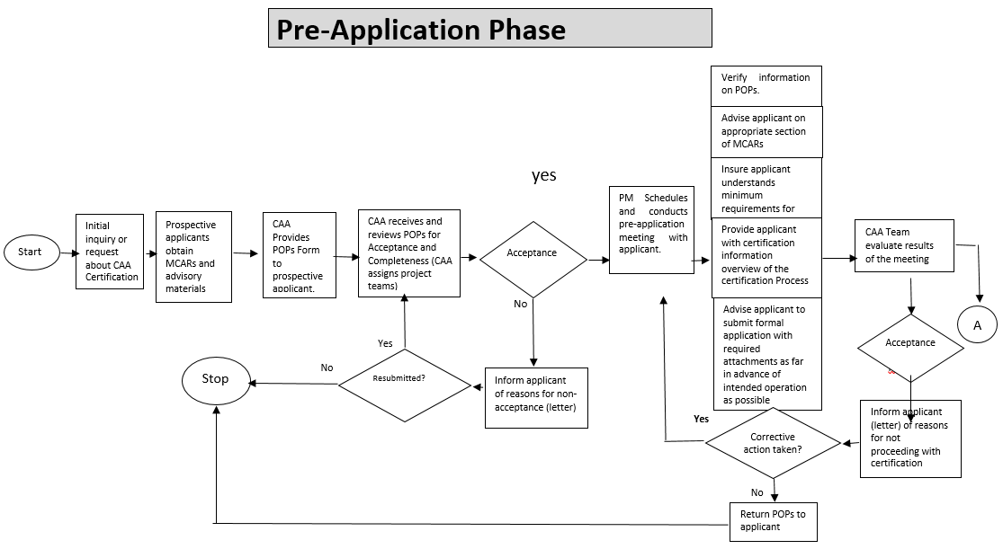
- Formal Application Phase
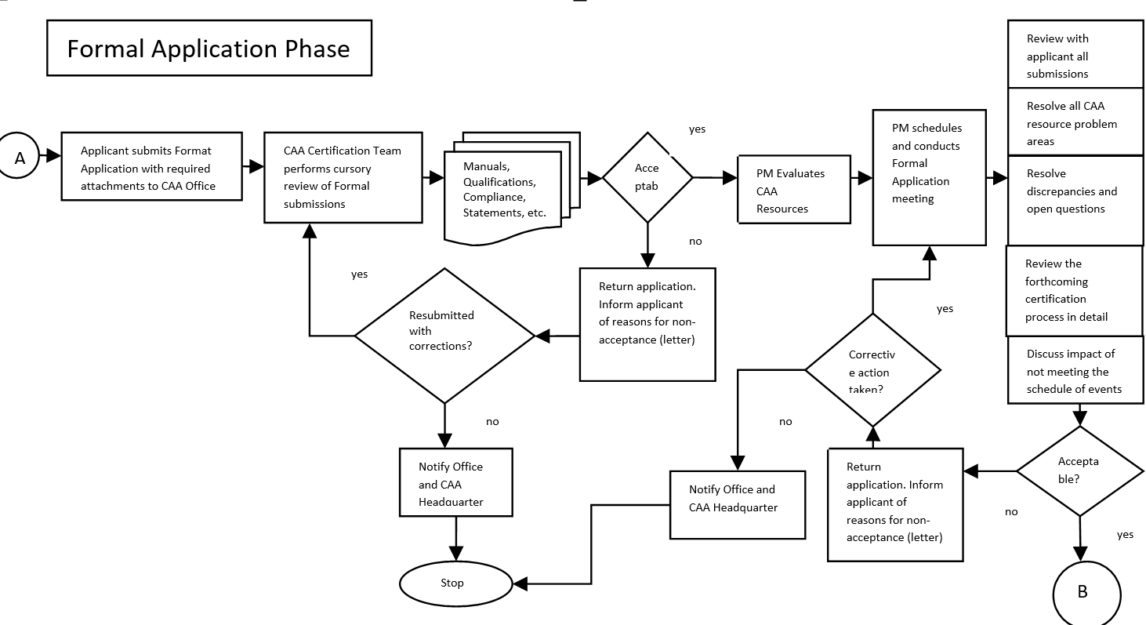

- Document Evaluation Phase
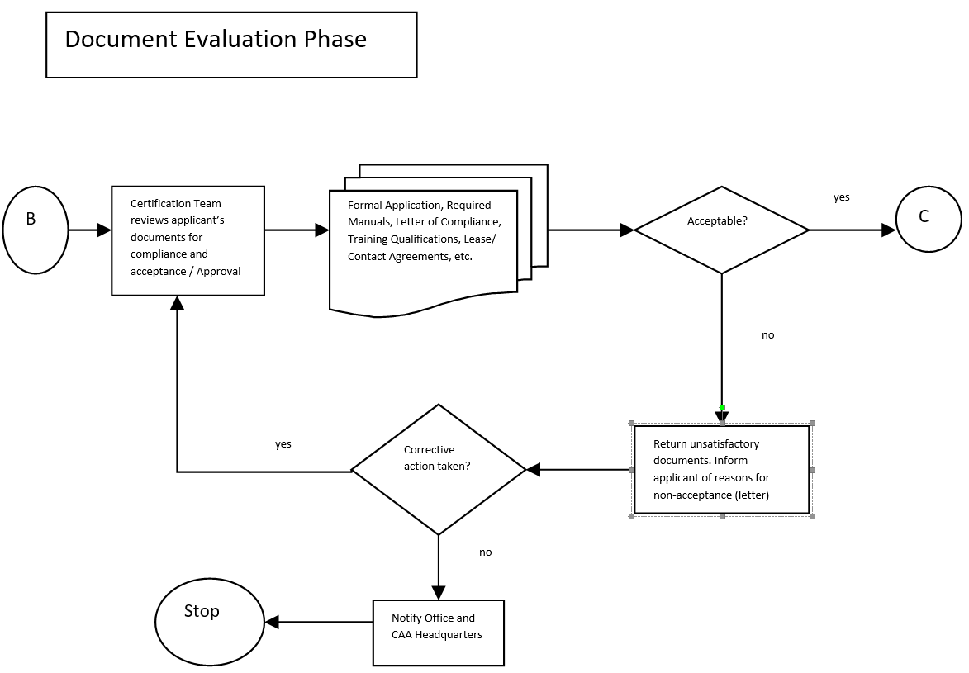
- Demonstration & Inspection Phase
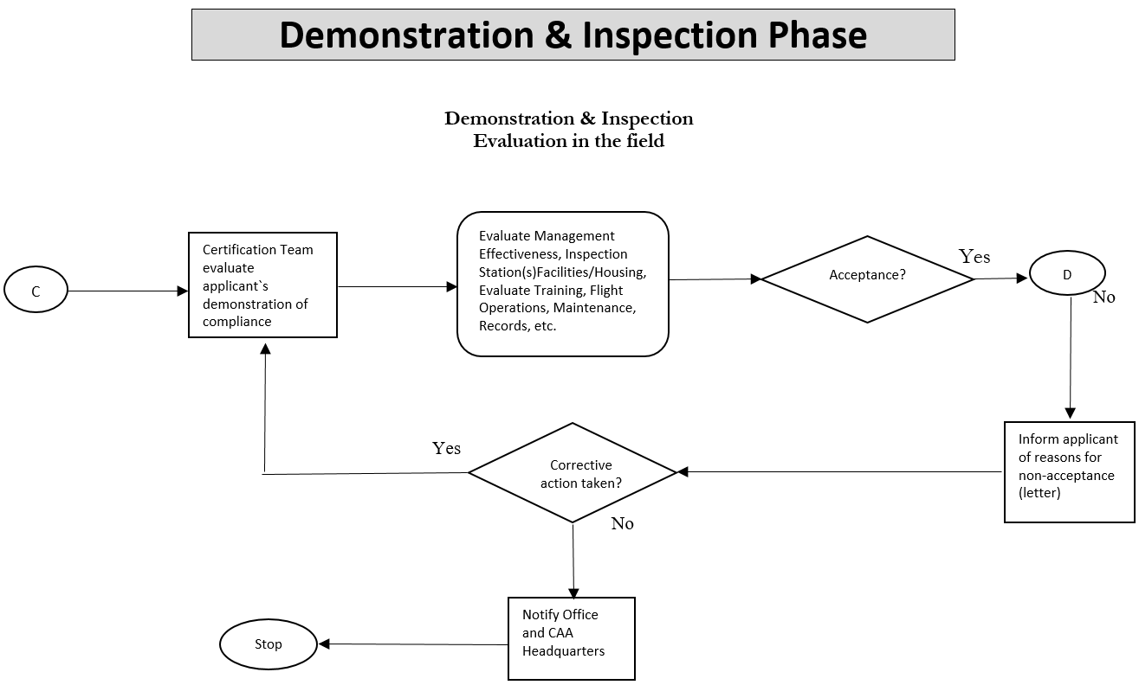
- Certification Phase
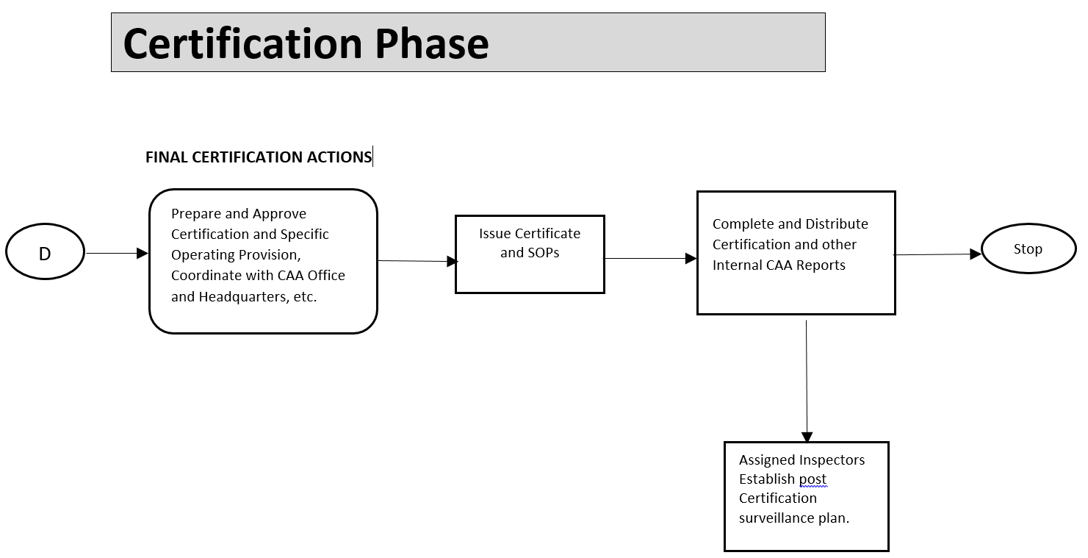

GM 8 Air Operator License

APPLICATION for an AIR OPERATING LICENCE

APLIKIMI PER LICENSE OPERIMI TE TRANSPORTUESIT AJRORE

Note (Shënim):
The signed original of this form and related documentation should be sent to the Director General for Civil Aviation Authority, Tirana, Albania.
Kopja origjinale e kësaj forme dhe dokumentat përkatës duhet të dërgohen te Drejtori Ekzekutiv i Autoritetit të Aviacionit Civil, Tiranë, Shqipëri.

Name of Applicant:
(including any trading name)
Emri i Aplikantit:
(përfshirë emërin tregtar)
Address:
Adresa:
Telephone Number:
Numër Telefoni:
Fax Number:
Numër Faksi:
e-mail address:
Adrese e-mail-i:
Principal Place of Business:
Selia Qendrore e Biznesit:

Do you hold an AOC?
A keni një AOC?
If yes, please give number.
Nëse po, ju lutemi jepni numrin e saj.
If no, have you appliced for one?
Nëse jo, a keni aplikuar?
Number and type of aircraft currently employed:
Numri dhe tipi i avionit në punë aktualisht:
Maximum seating capacity of largest aircraft employed:
Kapaciteti maksimal i vendeve të avionit më të madh:
Maximum cargo capacity of the largest all cargo aircraft employed:
Kapaciteti maksimal i ngarkesës në avionin më të madhë të ngarkesës:

Please state:
Ju lutem specifikoni:
- (1) the places between wich flights will be operated or, in the case of an application for an area licence, the geographical areas of origin and destination:
vendet midis të cilave do të operojnë fluturimet ose, në rastin e aplikimit për një license zone, zonat gjeografike të origjinës dhe destinacionit:

Origin Destination (& vice versa)
Origjina Destinacionet (kthimet anasjelltas)

- (2) any other limitations to which the license is to be subject, including limitations as to the capacity, frequency or class of service or the classes or descriptions of passengers or cargo to be carried:
ndonjë kufizim tjetër për të cilat licensa bëhet subjekt, duke përfshirë kufizimet si në
kapacitet, frekuence apo klase sherbimi ose klasat apo pershkrimet e pasagjereve ose kargos të cilët do transportohen:

Please provide corporate details as follows:
Ju lutemi jepni detajet e korporatës si më poshtë:
Registered address:
Adresa e regjistrimit:

Date and place of incorporation:
Data dhe vendi i përfshirjes:

Company registration number:
N umri i regjistrimit të kompanisë:

SHAREHOLDERS
AKSIONERET

Please list below the details of each person or company holding more than 5% of the total issued shares in the applicant. In the case of nominee holdings, indicate the name of the beneficial holder of the shares.
Ju lutemi listoni më poshtë detajet e secilit person apo zotërues kompanie me më shumë se 5% të aksioneve totale të lëshuara në aplikim. Në rastin e aksioneve të nominuara, vendosni emrin e mbajtësit potencial të aksioneve.

Full name of Shareholder Emri i plotë i  Aksionerit | Nationality  Kombësia | Number of shares  Numri i aksioneve | Class of shares  Kategoria e aksioneve | % of total issued  Përqindja
Name of parent company (if any) and date and place of incorporation:
Emri i kompanisë mëmë (nese ka) dhe data e vendi i përfshirjes:
Name of ultimate holding company (if any) and date and place of incorporation:
Emri i kompanisë zotëruese së fundmi (nëse ka) dhe data e vendi i përfshirjes:
List of enclosed documentation supporting this application:
Refer to Attachment A and B to this form for the conditions, guidance and necessary documentation to support this application
Lista e dokumentacionit bashkëlidhur që mbështet këtë aplikim:
Referohuni Shtojcës A dhe B të kësaj forme për kushtet, udhëzimet dhe dokumentacionin e nevojshëm për të mbështetur këtë aplikim

c

Application and Declaration
I, the undersigned, hereby apply for the grant of licence as described in this application and I declare that, to the best of my knowledge and belief, the statements given in this application are true.
Aplikimi dhe Deklarata
Unë, i nënshkruari, aplikoj për marrjen e licensës sic përshkruhet në këtë formë dhe deklaroj se, në të mirë të njohurive dhe besimit tim, deklaratat e dhëna në këtë aplikim janë të vërteta.

Name: Signature:
Emri: Nënshkrimi:

Position in Company: Date:
Pozicioni në Kompani: Data:

(Attachment 1)
Conditions for Granting on Operating Licence
(Shtojca 1)
Kushtet për dhënien e një license
The issue of an Operating Licence by the Albanian Civil Aviation Authority to an undertaking is regulated by the provisions of Regulation (EC) No 1008/2008 and Ministry Order No 17, date 02.09.2010 "On common rules for the operation of air services". In particular article 4 of Regulation 1008/2008 conditions the grant of an operating licence to the satisfactory compliance with the following:
Lëshimi i një License Operimi nga Autoriteti i Aviacionit Civil Shqiptar një sipërmarrjeje është e rregulluar me dispozitat e Rregullores (KE) Nr 1008/2008 dhe Udhezimi i Ministrit Nr. 17, date 02.09.2010 i ndryshuar me Udhezimin Nr 14 datë 9.9.2011"Mbi rregullat e zbatueshme të operimit në fushën e "sherbimeve ajrore". Në vecanti neni 4 te Rregullores 1008/2008, kushtet e dhënies së një license operimi janë si më poshtë:
1 | The undertaking's principal place of business is located in Albania  Selia kryesore e sipërmarrjes të jetë në Shqipëri
2 | The undertaking holds a valid AOC issued by Albania  Sipërmarrja të mbajë një COA të vlefshme të lëshuar nga Shqipëria
3 | The undertaking has one or more aircraft at its disposal through ownership or a dry lease agreement  Sipërmarrja ka një ose më shumë avione në dispozicion të saj nëpërmjet aktit të pronësisë ose nëpërmjet një kontrate "dry lease"
4 | The undertaking's main occupation is to operate air services in isolation or combined with any other commercial operation of aircraft or the repair and maintenance of aircraft  Objekti kryesore i sipemarrjes eshte qe te kryeje sherbime ajrore ne menyre te izo/uar ose kombinuar me ndonje operim komercia/ te avionit ose riparim dhe mirembajtje te avionit
5 | Its company structure is such as to allow the proper implementation of the provisions of Regulation (EC) 1008/2008 and
6 | Struktura e kompanise eshte e ti/le ne menyre qe te /ejoje implementimin e dispozitave te Rregullores (KE) 1008/2008 dhe Udhezimi i Ministrit Nr. 17, datë 02.09.2010 i ndryshuar me Udhëzimin  Nr. 14 datë 9.9.2011"Mbi rregullat e zbatueshme të operimit në fushën e shërbimeve ajrore"
7 | The undertaking meets the financial conditions as explained in Attachment B, Article 6 of Ministry Order Nr. 17  Sipermarrja duhet të respektojë kushtet financiare të shpjeguara në Shtojcën B sipas nenit 6 të udhëzimit nr. 17
8 | The undertaking complies with the insurance requirements specified Regulation (EC) No 785/2004  Sipermarrja tejete ne perputhje me kerkesat e sigurimit te specifikuara ne Rregulloren (KE) Nr.785/2004 ligjin nr. 10076 dt 12.02.2009 "Për sigurimin e detyrueshëm në sektorin e transportit"
9 | The persons managing the operations of the undertaking comply with the provisions on good repute (Article 7 of Reg (EC) No 1008/2008).  Personat të cilët menaxhojnë operacionet e kompanisë në përputhje me dispozitat për reputacion të mirë (Neni 7 i Rregullores (KE) Nr. 1008/2008 neni 8 i Udhezimit Nr. 17).

Definitions:
Përkufizime:

"Principal place of business" means the head office or registered office of a Community air carrier in the Member State within which the principal financial functions and operational control, including continued airworthiness management, of the Community air carrier are exercised.

"Selia kryesore e biznesit" është vendndodhja qëndrore ose zyra e regjistruar e një transportuesi ajror të Komunitetit në Shtetin Anetar në të cilin ushtrohen funksionet kryesore financiare dhe të kontrollit operacional, duke përfshirë edhe menaxhimin e vazhdueshëm të aftësisë së fluturimit, të transportuesit ajror të Komunitetit.
"Business plan" means a detailed description of the air carrier's intended commercial activities for the period in question, in particular

"Plani i biznesit" është përshkrimi i detajuar i aktiviteteve komerciale të synuara të transportuesit ajror në vecanti për periudhen në fjalë.

(Attachment 2)
(Shtojca 2)
Financial Conditions for Granting on Operating Licence
Kushtet Financiare per Dhenien e nje License Operimi
1 | An undertaking applying for the first time for an operating licence shall demonstrate that:  Një sipërmarrje që aplikon për herë të parë për një license operimi duhet të provojë se:  - (a) it can meet at any time its actual and potential obligations established under realistic assumptions, for a period of 24 months from the start of operations, and  ajo mund të në cdo kohë detyrimet e saj aktuale dhe potenciale të krijuara sipas supozimeve reale, për një periudhë kohe prej 24 muajsh që prej fillimit të operimit, dhe  - (b) it can meet its fixed and operational costs incurred by operations, according to its business plan and established under realistic assumptions, for a period of three months from the start of operations, without taking into account any income from its operations  ajo mund të përmbush kostot fikse dhe operacionale të shkaktuara nga operacionet, sipas planit të biznesit dhe sipas supozimeve reale, për një periudhë kohore prej 3 muajsh që prej fillimit të operimit, pa marrë parasysh asnjë të ardhur nga operacionet e saj
2 | For the purposes of the assessment referred to in paragraph 1,each applicant shall submit a business plan for, at least, the first three years of operation.The business plan shall also detail the applicant's financial links with any other commercial activities in which the applicant is engaged either directly or through related undertakings. The applicant shall also provide all relevant information, in particular the data referred to in point 1of Annex I.  Për qellime të vlerësimit të reJeruar në paragrafin 1, çdo aplikant duhet të dorëzojë një plan biznesi, për të paktën 3 vitet e para të operimit. Plani i biznesit duhet të ketë të detajuara lidhjet financiare të aplikantit me ndonjë aktivitet tjetër tregetar në të cilin aplikanti është i angazhuar drejtpërdrejt ose nëpërmjet një sipërmarrjeje që ka lidhje. Aplikanti duhet të japë informacionin që lidhet me këtë, e në vecanti të dhenat e referuara në pikën 1 të Aneksit I.
3 | Paragraphs 1and 2 shall not apply to an undertaking applying for an operating licence intended to cover operations with aircraft of less than 10 tonnes maximum take-off mass (MTOM) and/or less than 20 seats. Such undertakings shall demonstrate that their net capital is at least EUR 100,000 or provide, when required by the competent licensing authority, all relevant information for the purposes of the assessment referred to in paragraph 1,in particular the data referred to in point 1 of Annex I.  Paragrafet 1 dhe 2 nuk do të aplikohen në aplikimin e një sipërmarrje për një licensë operimi që ka për qëllim të mbulojë operacione me një avian me më pak se 10 ton maksimumi (MTOM) dhe/ose më pak se 20 vende. Sipërmarrje te tilla do të provojnë se kapitali i tyre neto është të paktën 100,000 Euro ose të japin nëse kërkohet nga autoriteti kompetent licensues, të gjitha informacionet përkatëse për qëllimet e vlerësimit të reJeruarr në paragrafin 1, në vecanti të dhënat e referuara në pikën 1 të Aneksit I.
The ACAA may nevertheless apply paragraphs 1and 2 to an undertaking applying for an operating licence under the provisions of the previous subparagraph that intends to operate scheduled air services or whose turnover exceeds ER 3 million per year.
AAC-ja gjithsesi mund ta aplikoje paragrafet 1 dhe 2 të një aplikimi të një sipërmarrje për një leje operimi në përputhje me dispozitat e nënparagrafit të mëparshëm që ka për qëllim të operojë sherbimet ajrore të programuara ose te ato që xhirot i tejkalon 3 milion euro në vit.

Annex I to Attachment 2

Aneksi I i Shtojcës 2
Information to be provided for the grant of an Operating Licence:

Jnformacioni që duhet të jepet për dhenien e një License Operimi:
- Information to be provided by a first-time applicant from a financial fitness point of view.

lnformacioni që duhet të jepet për një aplikant për hëre të parë nga një këndvështrim i përshtatshmërisë financiare
  - The most recent internal management accounts and, if available, audited accounts for the previous financial year.
c

Llogaritë më të fundit të menaxhimit të brendshëm dhe, nëse ka, llogaritë e audituara për vitin financiar paraardhës.
  - A projected balance sheet, including profit-and-loss account, for the following three years.

Një bilanc të projektuar, duke përfshirë evidencën e të ardhurave dhe shpenzimeve, për 3 vitet në vazhdim.
  - The basis for projected expenditure and income figures on such items as fuel, fares and rates, salaries, maintenance, depreciation, exchange rate fluctuations, airport charges, air navigation charges, ground handling costs, insurance, etc. Traffic/ revenue forecasts.
Baza për shifra të projektuara të ardhurash dhe shpenzimesh mbi zëra të tilla si karburant, çmimet dhe tarif at, pagat, mirëmbajtja, amortizimi, mhajtja e kursit tekëmbimit, tatime të aeroportit, tatimet e lundrimit ajror, kosto e shërbimeve në tokë siguracione etj. Parashikimi i Trafikut/ të ardhurave.
  - Details of the start-up costs incurred in the period from submission of an application to the commencement of operations and an explanation of how it is proposed to finance these costs.

Detaje të kostove fillestare të kryera në përiudhën nga paraqitja e kërkesës deri në nisjen e operacioneve dhe një shpjegim se si propozohet të financohen këto kosto.
  - Details of existing and projected sources of finance.

Detaje të burimeve ekzistuese dhe të projektuara të financimit
  - Details of shareholders, including nationality and type of shares to be held, and the Articles of Association. If part of a group of undertakings, information on the relationship between them has to be provided.

Detaje të aksionereve, duke përfshirë shtetësinë dhe tipin e aksioneve që disponojnë, dhe
Marrëveshjen e Shoqatës Aktin e Themelimit. Nëse është pjesë e një grupi sipërmarrjesh, duhet të jepet informacioni në lidhje me marrëdheniet midis tyre
  - Projected cash-flow statements and liquidity plans for the first three years of operation.
Parashikimi i pasqyrave të fluksit të parasë dhe planet e likuiditetit për tre vitet e para të operimit.
  - Details of the financing of aircraft purchase/leasing including, in the case of leasing, the terms and conditions of contract.
Detaje të financimit të blerjes avionit/ qerasë, në rast se janë marreë me qera, afatet dhe kushtet e kontratës.
- Information to be provided for assessment of the continuing financial fitness of existing licence holders planning a change in their structures or in their activities with a significant bearing on their finances.
lnformacioni që duhet të jepet për vlerësimin e përshtatshmërisë së vazhdueshme
financiare të mbajtësve ekzistues të licensave që planifikojnë një ndryshim në strukturat e tyre ose në aktivitetet e tyre që sjell një ndryshim të rëndësishme në financat e tyre.
  - If necessary, the most recent internal management balance sheet and audited accounts for the previous financial year.
Nëse është e nevojshme, bilanci më i fundit i menaxhimit të brendshëm dhe llogaritë e audituara të vitit financiar paraardhës.
  - Precise details of all proposed changes e.g. Change of type of service, proposed takeover or merger, modifications in share capital, changes in shareholders, etc.
Detajet e sakta të të gjitha ndryshimeve të propozuara si p.sh. Ndryshimi i tipit të
shërbimit, blerje apo shkrirje, modifikimet në kapitalin aksionar, ndryshime në pronësinë e aksioneve, etj.
  - A projected balance sheet, with a profit-and-loss account, for the current financial year, including all proposed changes in structure or activities with a significant bearing on finances.
Një bilanc të projektuar, me pasqyrën e të Ardhurave e Shpenzimeve, për vitin financiar aktual, duke përfshirë të gjitha ndryshimet e propozuara në strukturë ose aktivitetet me një influence ë rëndësishme për financat e tyre
2.4 Past and projected expenditure and income figures on such items as fuel, fares and rates, salaries, maintenance, depreciation, exchange rate fluctuations, airport charges, air navigation charges, ground handling costs, insurance, etc. Traffic/ revenue forecasts.
Shifra të ardhurash dhe shpenzimesh të projektuara dhe të shkuara për zero të tillë si karburant, çmimet dhe tarifat, pagat, mirëmbajtja, amortizimi, luhatja e kursit të këmbimit, tarif at aeroportuale, tarif at e lundrimit ajror, kosto të sherbimeve në tokë, siguracione, etj.Parashikimi i trafikut/ të ardhurave.

2.5 Cash-flow statements and liquidity plans for the following year, including all proposed changes in structure or activities with a significant bearing on finances.
Pasqyra e f luksit të parave dhe likuiditeteve të planifikuara për vitin në vazhdim, duke përfshirë të gjitha ndryshimet e propozuara në strukturë apo në aktivitete me një influence të rëndësishme në financa.

2.6 Details of the financing of aircraft purchase/ leasing including, in the case of leasing,the terms and conditions of contract.
Detaje për financimin e blerjes së avionit/ qerasë, dhe në rast se është marrë me qera, afatet dhe kushtet e kontratës.

- Information to be provided for assessment of the continuing financial fitness of existing licence holders.
lnformacioni që duhet të jetë për vleresimin e përshtatshmërisë së vazhdueshme financiare për mbajtësit ekzistent të licenses.
3.1 Audited accounts no later than six months, following the last day of the relevant financial year, unless otherwise provided for in national law and, if necessary, the most recent internal management balance sheet.
Llogaritë e audituara jo më vonë se 6 muaj, pas ditës së fundit të vitit përkatës financiar,pervecse nëse parashikohet ndryshe në ligjin kombetarë dhe, nëse do të jetë e nevojshme, bilancin me të fundit të menaxhimit të brendshem.
  - A projected balance sheet, including profit-and-loss account, for the forthcoming year.
Një bilanc të projektuar, duke përfshirë llogarinë e të ardhurave dhe shpenzimeve, për vitin e ardhshëm.
  - Past and projected expenditure and income figures on such items as fuel,fares and rates, salaries, maintenance, depreciation, exchange rate fluctuations, airport charges, air navigation charges, ground handling costs, insurance, etc. Traffic/ revenue forecasts.
l_
Të dhënat e të ardhurave dhe shpenzimesh të projektuara dhe të kaluara për zëra të tilla si karburant, çmimet dhe tarifat, pagat, mirëmbajtja, amortizimi, luhatja e kursit të këmbimit, tarif at aeroportuale, tarif at e lundrimit ajror, kosto e sherbimeve në tokë, siguracione etj. Parashikimi i Trafikut/ të ardhurave.
3.4 Cash flow statements and liquidity plans for the following year.
Pasqyrat e fl uksit të parave dhe të llikuiditetit të planifikuara për vitin nëvazhdim.

AIRCRAFT REGISTRATION PROCEDURE
General
Aircraft registration functions in the ACAA are regulated by Minister of Transport Order No. 113 dated 12/10/2012 “On Aircraft Registration”.
An aircraft can be registered in the ACAA Register if it is owned and/or is operated by an Albanian citizen, or by a company established as per applicable requirements and that is based in the Albanian Territory.
When importing aircraft to the Republic of Albania, the Export Certificate of Airworthiness (Export CofA) shall have to be obtained from the previous registry state. Aviation authorities of the previous registry state shall verify in Export CofA that an aircraft complies with the approved type certificate, that it is airworthy and that it complies with the national requirements in the importing country, respectively Republic of Albania.
When registering an aircraft, the ACAA inspector shall ensure that the aircraft is not registered in another state. This is verified by the deregistration certificate issued by the previous state of registry.
Aircraft import and issuance of Certificate of Airworthiness and Airworthiness Review certificate are regulated by:
Minister of Transport Order No. 149 dated 07/04/2014 transposing Commission Regulation (EU) No 748/2012 of 3 August 2012 laying down implementing rules for airworthiness and environmental certification of aircraft and related products, parts and appliances, as well as for the certification of design and production organisations.
Minister of Transport Order No. 110 dated 02/10/2012 transposing Commission Regulation (EC) 2042/2003 of 20 November 2003 on the continuing airworthiness of aircraft and aeronautical products, parts and appliances, and on the approval of organisation and personnel involved in these tasks and Commission Regulation (EC) 1321/2014 of 17/12/2014.
Registration procedure
The owner of the aircraft must send an official request to ACAA and Aircraft Classification Report as per the “Registration Application Form”(DAMO-AWM-FRM-001);
Evaluation of the document presented by the ACAA assigned inspector/team.
Planning and performing an aircraft physical inspection of the aircraft as per AWM-CHK-005 “Aircraft Registration checklist”
If the inspection result is OK than will proceed on issuing of Certificate of Registration and aircraft shall entered into Albanian Civil Aviation Register.
A fee is charged to register an aircraft and it will be made known by the ACAA at the time of registration. The fee is applicable as per Mutual Regulation No 2225 dated 13/05/2013 of Minister of Transport and Minister of Finance.

Noise Certification
Any natural or legal person under whose name an aircraft is registered or will be registered in Albania, or its representative, shall be eligible as an applicant for a noise certificate for that aircraft as per requirements of M.O. Nr. 149/2014 (EU 748/2012).
The owner shall make an official application for issuing of Noise Certificate as per the form DAMO-AWM-FRM-006.
After ACAA makes the evaluation of the application and supporting documents and finds them in order it will issue the Noise Certificate for the aircraft.
Application for Mode S code
After the aircraft registration the owner shall make the application to ACAA for assignment of ICAO 24-bit aircraft address (Mode S code application) as per the form DAMO-AWM-FRM 018.
After the evaluation of the application ACAA shall assign the Mode S code for the registered aircraft.

Radio licences
For the operation of the aircraft it is required a radio licence to be issued for this aircraft. Aeronautical Radio Licences are not transferable, so licences held in the previous owner's name are not valid.
The application for radio licensing shall be made to the “Authority for Electronic and postal communication” (AKEP).
CONTINUING AIRWORTHINESS OF AIRCRAFT
Issuing of CofA and ARC
Application for Certificate of Airworthiness (CofA) shall be made in a written form to ACAA, as per the form DAMO-AWM-FRM-174 “Application for a CofA”, from the entitled person or from other subjects (e.g. CAMO, etc) to the ACAA. The request should be submitted to the ACAA at least two months before delivery of the aircraft or prior to initiation of operations.
Together with application form the following documents shall be sent to ACAA:
- For new aircraft the following must be submitted:
- A statement of conformity by a Approved Production Organization, or;
- A statement signed by the exporting authority that the aircraft conforms to a design approved by EASA, and;
- A Weight & Balance report with a loading schedule
- The AFM when required by the applicable airworthiness code for the particular aircraft.
- For used aircraft the following must be submitted:
- If originated from a Member State (EASA aircraft), an ARC issued in accordance with Part M.
- If originated from a Non-member State (Non-EASA aircraft)
- An Export CofA issued by the competent authority of the state of register, reflecting the airworthiness status at the time of transfer;
- A W&B report with a loading schedule;
- AFM when required by the applicable a/w code for the particular aircraft;
- Historical records to establish production, modification and maintenance standards of the aircraft including limitations (that can be combined with Aircraft Classification Report sent during the application for aircraft registration);
- Recommendation for issuing CofA/RCofA and ARC following an airworthiness review in accordance with Part M;
- Aircraft Maintenance Programme.
After the evaluation of the documents presented by the aircraft owner ACAA shall plan and perform an audit on documents and aircraft as per checklist DAMO-AWM-CHK-004 “CofA issuance” and DAMO-AWM-CHK-006 “Aircraft Airworthiness Review”.
After ACAA finds everything in order and all non-conformities are corrected it will issue the CofA or ARC for the aircraft concern.

CONTINUING AIRWORTHINESS MANAGING ORGANISATION (CAMO)
Initial Approval of CAMO
Organizations managing continuing airworthiness of aircraft (CAMO) have to be approved according to Part M Subpart G of the Minister of Transport Order No. 110 dated 02/10/2012 transposing Commission Regulation (EC) 2042/2003 of 20 November 2003 and Commission Regulation (EC) No 1321/2014 of 26 November 2014 on the continuing airworthiness of aircraft and aeronautical products, parts and appliances, and on the approval of organisations and personnel involved in these tasks.
The approval process contains a number of sub-processes as introduced in the AWM-PCS-003, below.

Pre-application.

Prior to formal application the applicant shall send a letter with the prospective organization prior to the submission of a formal application and have a meeting with ACAA/Airworthiness Section.
During this meeting, the ACAA representatives will make the potential organization aware of the regulatory requirements, which must be met in order to obtain the approval, documents to be submitted and of the exact process steps which must be accomplished before the issuance of the Certificate.
Application
The application phase starts with the official request signed by the AM (CEO) of the organization sent to ACAA. As per application form ACAA-DAMO-AWM-FRM-002A.
Together with application form, the applicant shall send to ACAA and following documents:
- Certificate of Corporate Registration;
- Formal Act delegating the Accountable Manager;
- Application Form for nominated CAMO postholder accompanied by documents to prove qualifications and competence as per the form DAMO-AWM-FRM-004 (for the other nominated persons, as well as compliance monitoring and safety manager the application shall be made as per the AOC procedures);
- CAME & organizational chart;
- Maintenance Program for aircraft managed and, where applicable, the baseline and generic MP;
- Reliability program, where appropriate;
- The Aircraft Tech Log System, if applicable;
- Where appropriate, technical specifications of the maintenance contracts between the owner and the AMO;
- Minimum Equipment Lists;
- The continuing airworthiness management arrangements, if applicable;
- Compliance checklist to Part M as per CAME Compliance List as per EC REG No 1321/2014;
- Internal Audit results
- Points of contact of the organization
The ACAA shall make the evaluation of the documents presented and shall communicate to the points of contact of the organization all discrepancies
Evaluation of Form 4 for the responsible persons of the organization; the CAMO post-holder; quality manager, ARS, etc, as well as evaluation of the qualification and experience evidences. After the evaluation of the managers’ files, the ACAA shall make an interview with the applicants and after positive results informs the organization for their acceptance.
The evaluation of the submitted manuals/documents is carried out by the assigned ACAA team to assess compliance with Part M Subpart G and related AMC requirements.

The approval of Manuals sent by the organization (CAME, MP, etc.) shall be made as per the following scheme
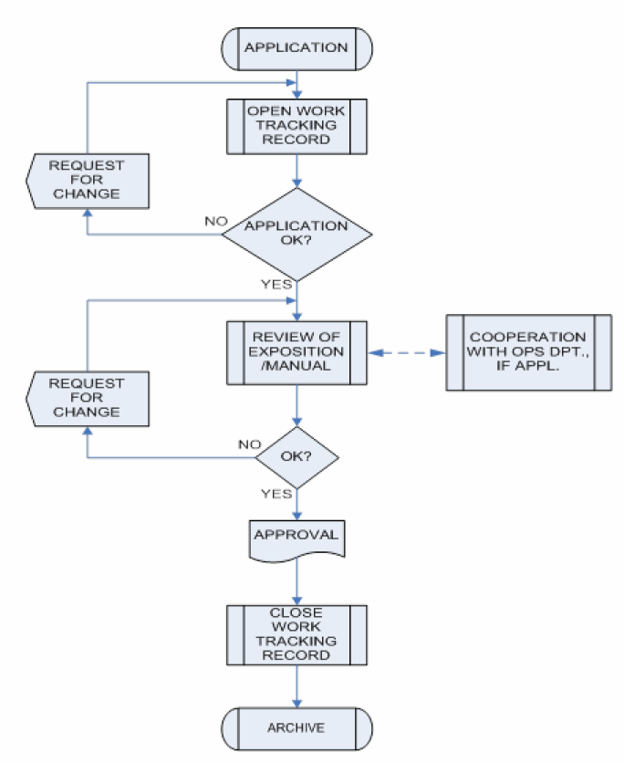

After the supporting documents, manuals and managers are considered acceptable, the team prepares the audit plan for the declared facilities, as per DAMO-AWM-CHK-016 “CAMO initial Certification Process”.
After all corrective actions have been taken by the applicant and all findings have been closed, the certification team prepares the CAMO Approval and gives it to the organization together with AOC.

Aircraft Continuing Airworthiness Monitoring
In order to have satisfactory oversight of aircraft airworthiness, aviation authorities shall implement aircraft continuing airworthiness monitoring (ACAM). National aviation authorities shall sample aircraft from the national register and check whether they are in the satisfactory airworthy condition, while also assessing the owner/user in the terms of aircraft continuing airworthiness maintenance and compliance with the requirements of the approval.

- Minister of Transport Order No.149 dated 07/04/2014 “On implementing rules for the airworthiness and environmental certification of aircraft and related products, parts and appliances, as well as for the certification of design and production organisations”, can be found on Official Gazette No.60 dated 28/04/2014.
- Minister of Transport Order No.110 dated 02/10/2012 “on the continuing airworthiness of aircraft and aeronautical products, parts and appliances, and on the approval of organisations and personnel involved in these tasks”, can be found on Official Gazette No.60 dated 28/04/2014
- Minister of Transport Order No.113 dated 12/10/2012 “on aircraft registration”, can be found on Official Gazette No.186 December 2012

